Project Topic: Online Train Ticket Booking System

Project Scope:

Design and implement a SQL database for an online train ticket booking system. The database should handle various aspects of the booking system, such as train schedules, customer information, ticket bookings, and administrative functions.

Steps to Implement the Project:

1. Database Design (DDL - Data Definition Language):

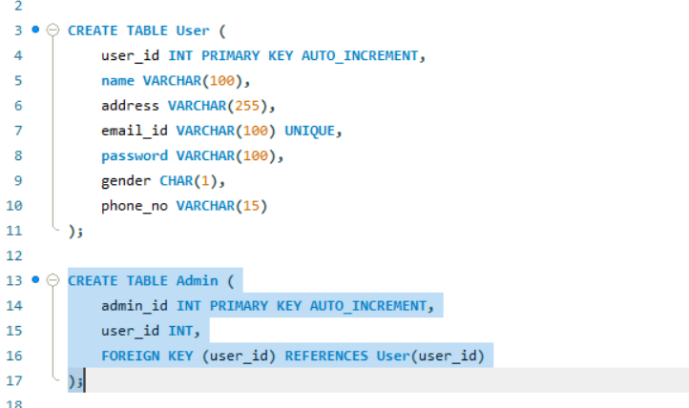

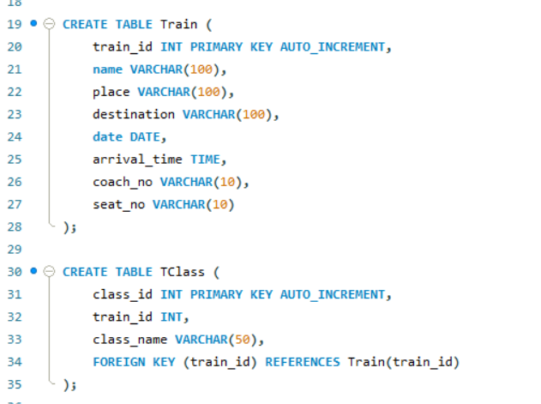

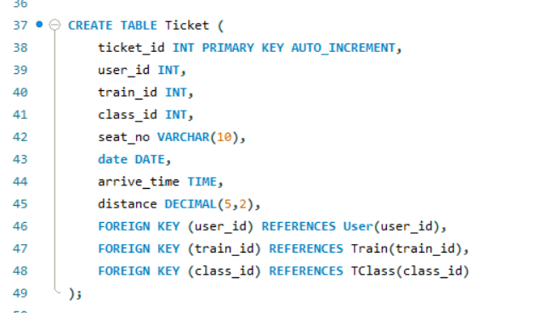

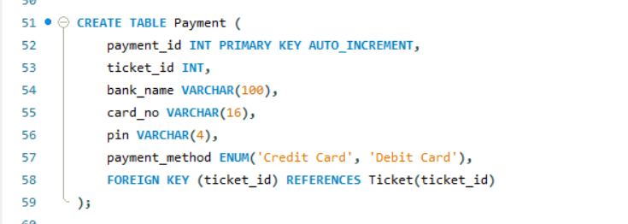

2. Populating Data (DML - Data Manipulation Language):

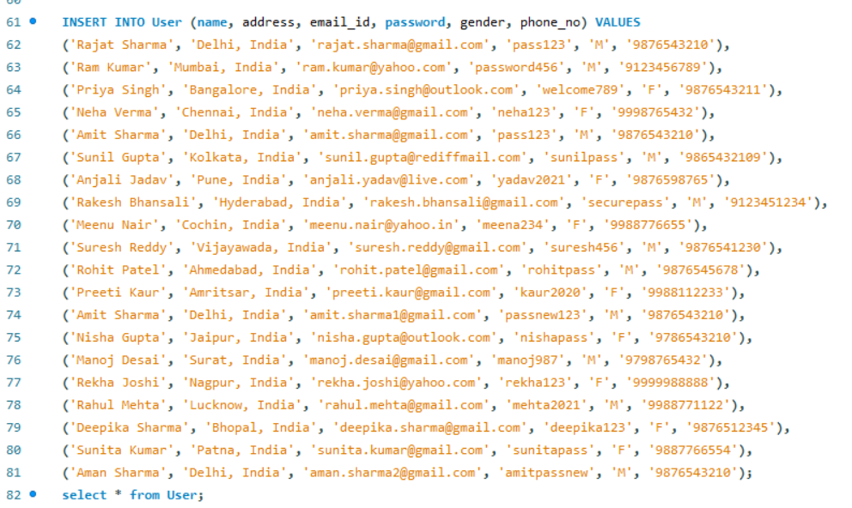

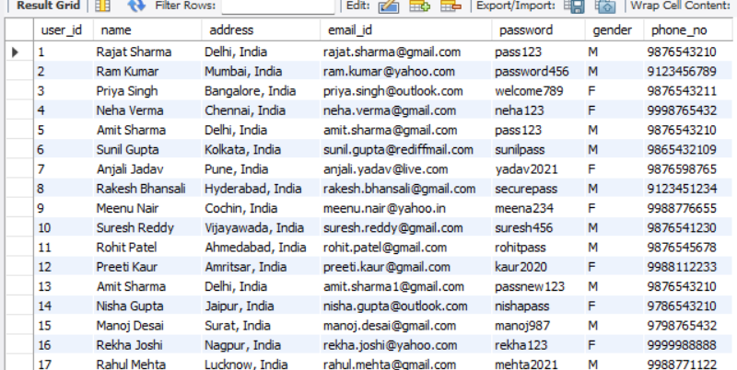

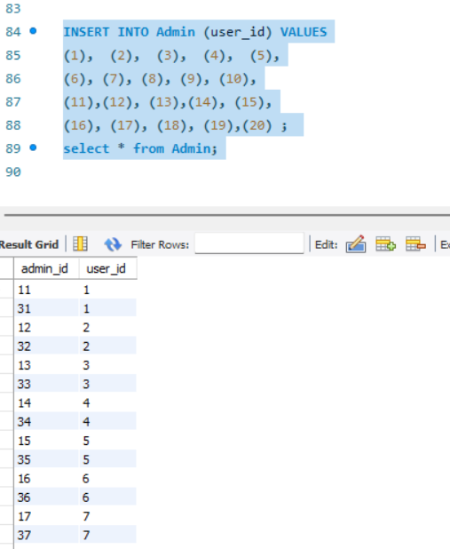

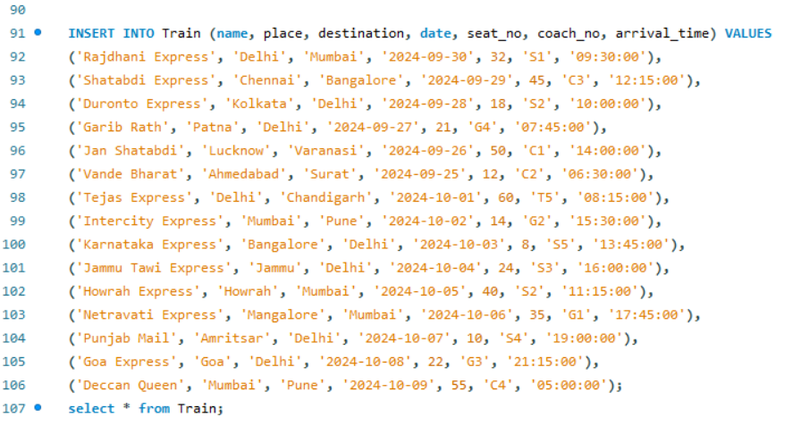

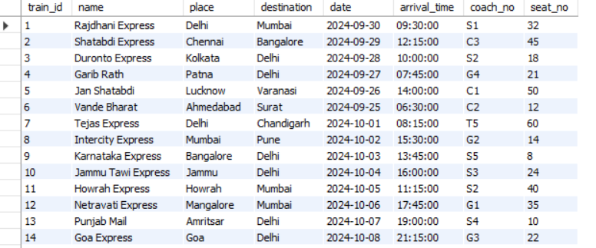

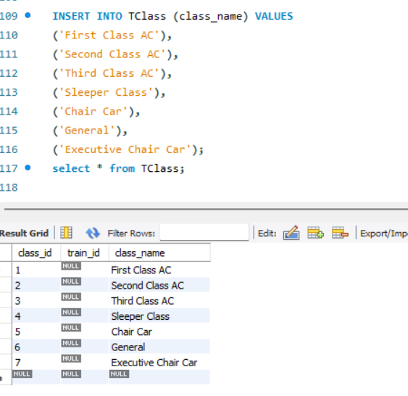

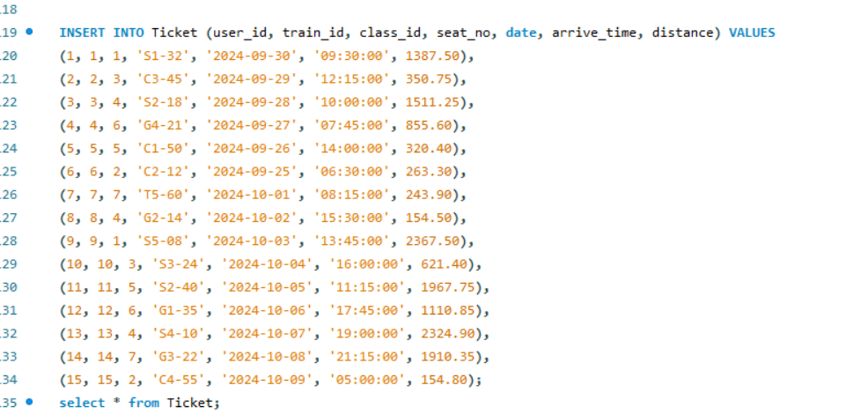

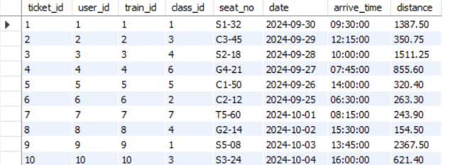

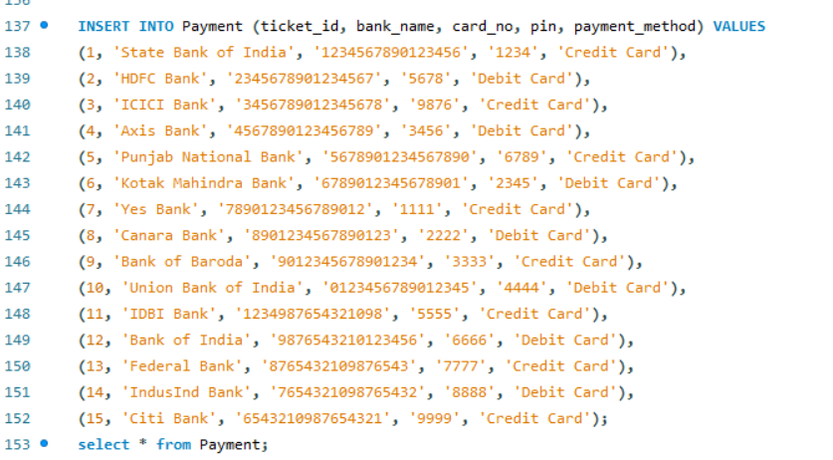

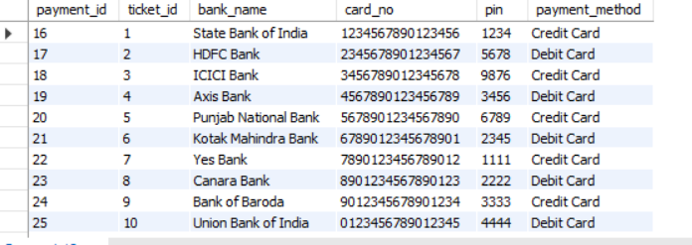

3. Querying Data (DQL - Data Query Language):

Count of Payments by Payment Method

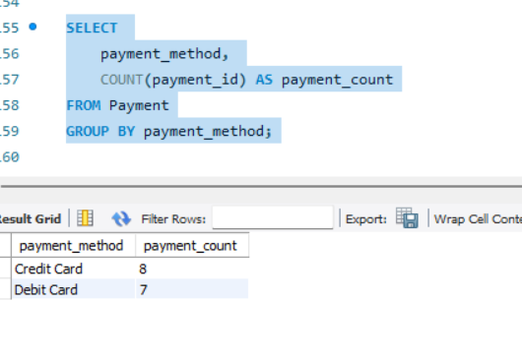

Total Payments by Bank

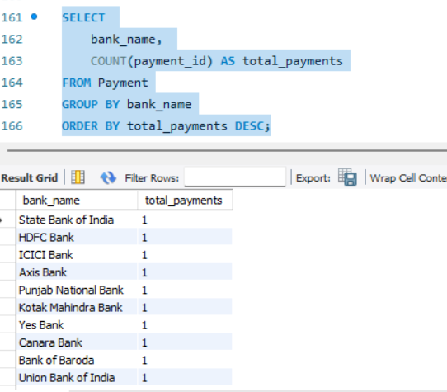

Retrieve Tickets for 30-09-2024

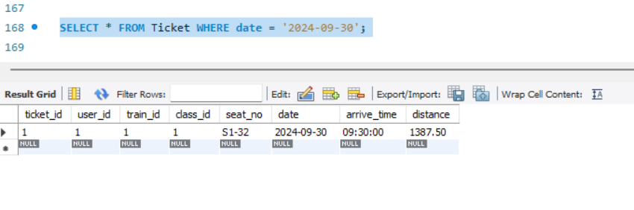

Find Tickets with a Seat Number in a Specific Range

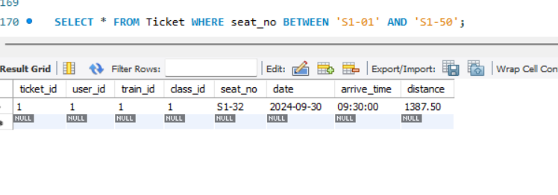

4. Advanced Queries and Subqueries:

Find Users Without Tickets

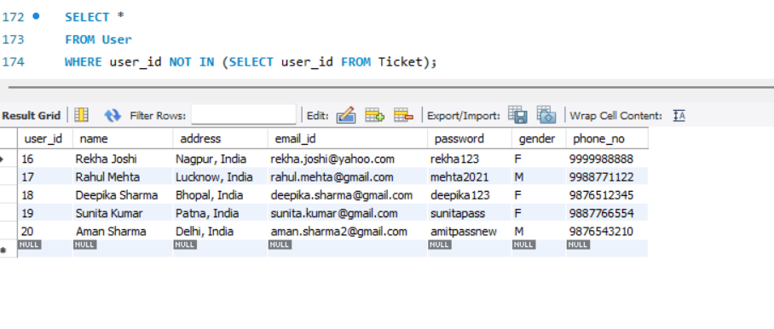

Find Users Who Paid Using a Credit Card

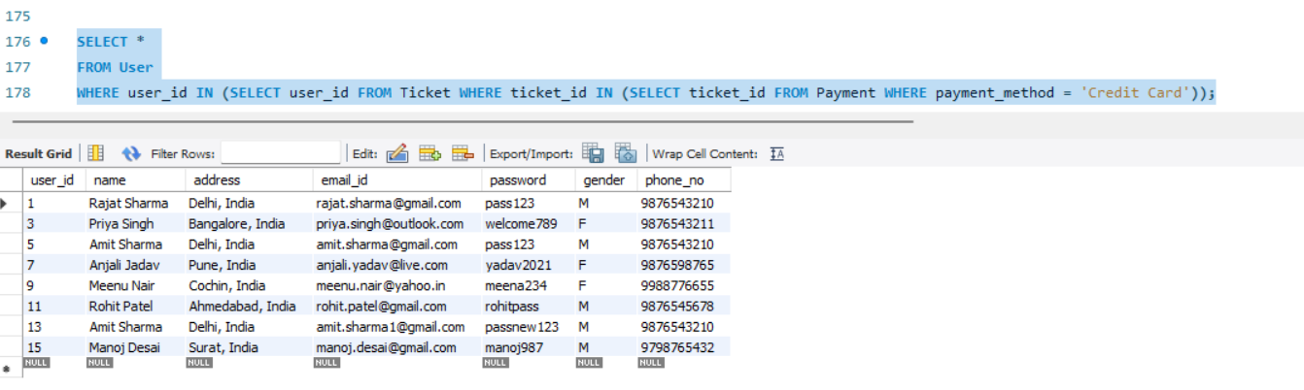

Find Users Who Have Taken a Train From Delhi

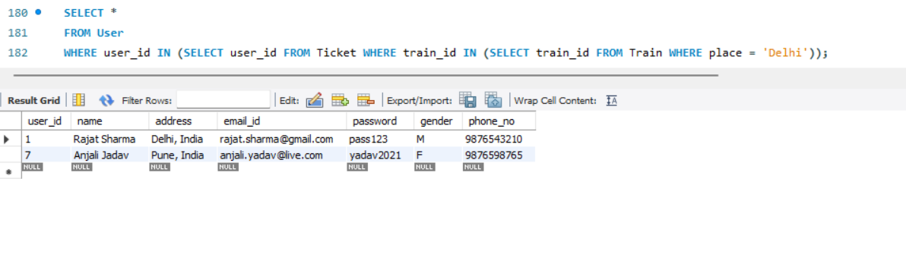

Find Users with the Shortest Name

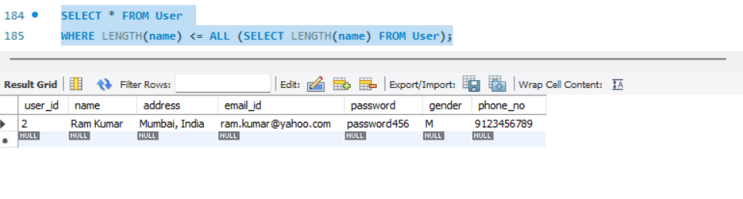

Find Users Whose User ID is Higher than Any User with name Amit Sharma

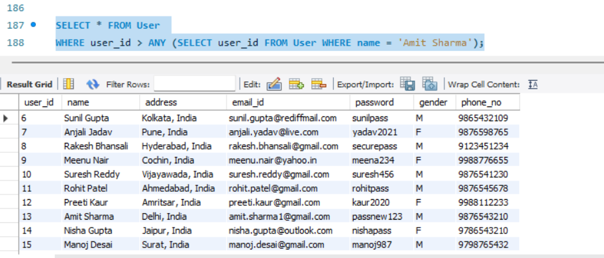

5. Using Joins:

List Users Who Have Booked Tickets and Made Payments

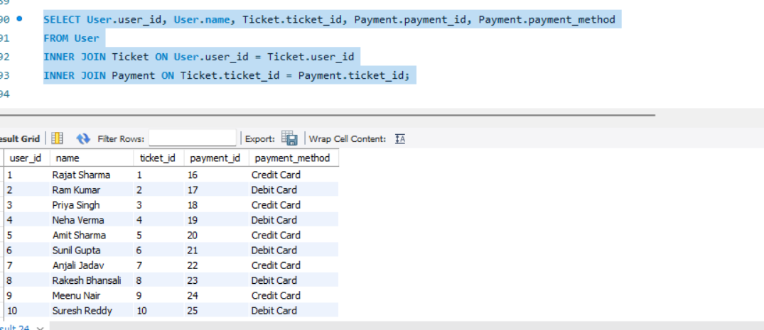

List All Trains and Their Tickets (Including Trains Without Tickets)

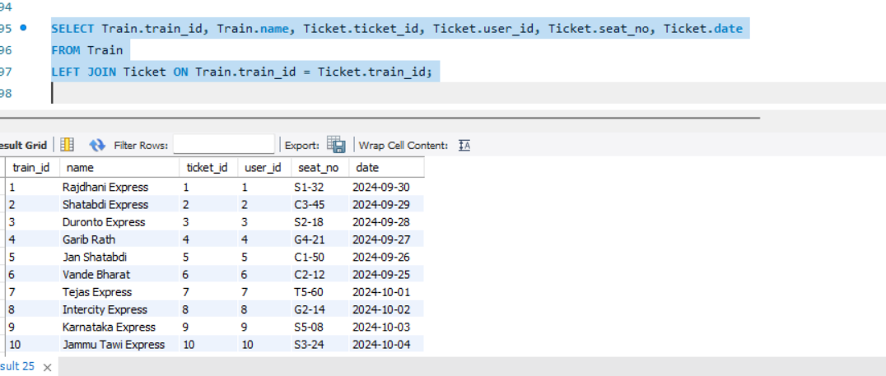

Find All Combinations of Users and Trains

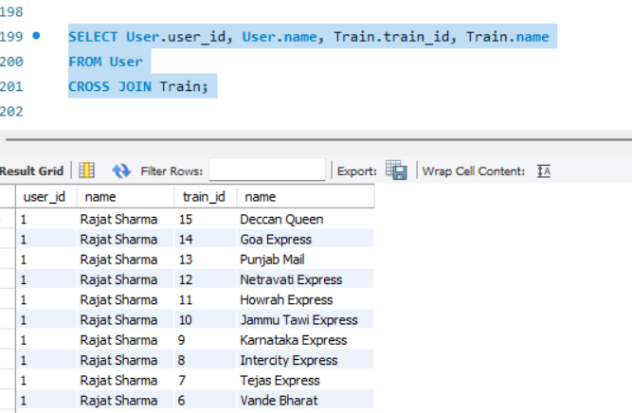

Union of Train Information and Ticket Booking

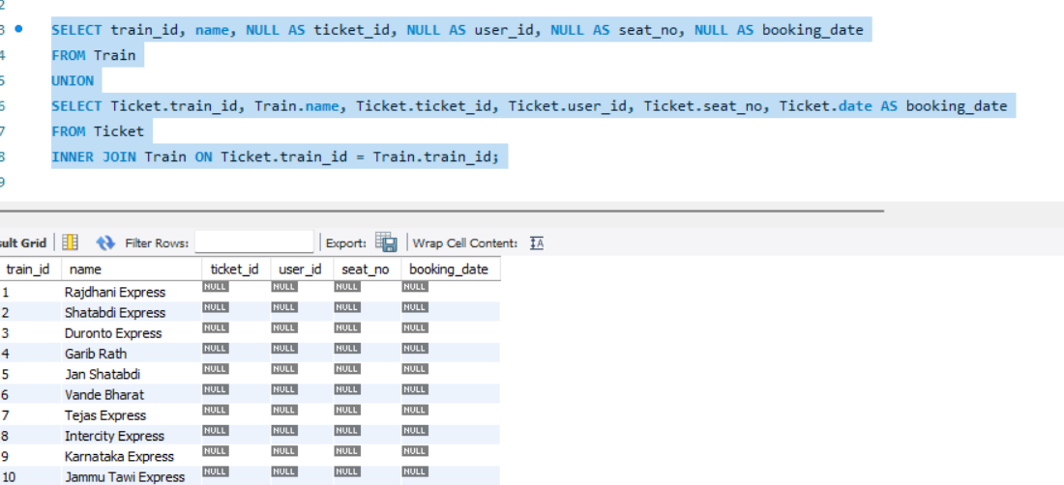

6. Creating Views:

User Details with Booked Tickets

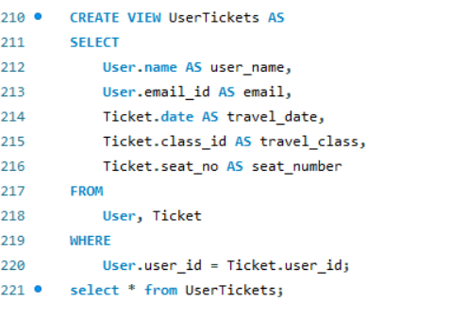

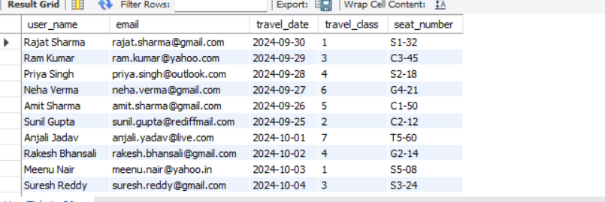

Train Schedule

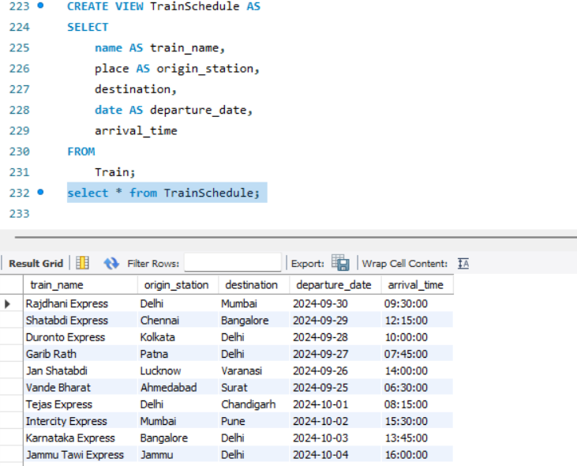

User Details

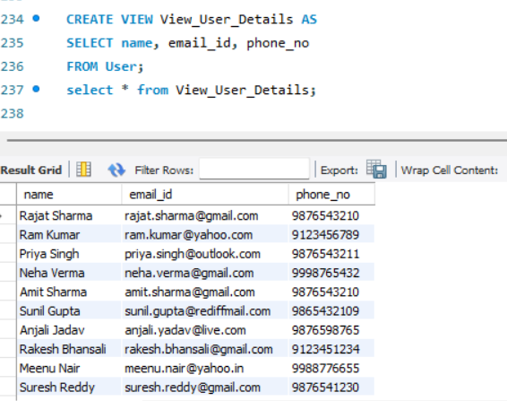

Ticket Details

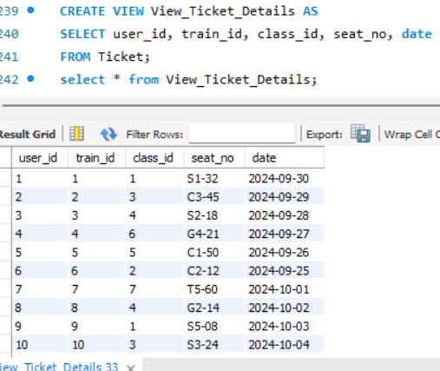

7. Documentation:

User Case Diagram -s a blueprint for the system's functionality.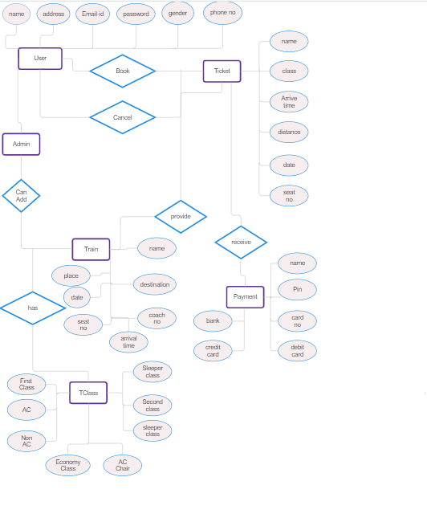

E R Diagram- is a blueprint for the database structure.

